PIPEDA Compliance for Log360
Strengthen data protection and meet PIPEDA compliance with Log360.
Region: Canada | Type: Data Privacy, Government/Public Sector | Category: Compliance | Pricing: Free

Overview
The PIPEDA compliance extension in Log360 helps organizations meet the Personal Information Protection and Electronic Documents Act (Canada), Canada's federal private-sector privacy law governing how commercial organizations collect and disclose personal information by providing centralized log management, security safeguard monitoring, and breach detection capabilities. The platform supports PIPEDA requirements for accountability, identifying purposes, consent, limiting collection, safeguards, accuracy, openness, individual access, mandatory breach reporting, and challenging compliance.
For Principles 1-2: Accountability and Identifying Purposes, Log360 monitors access to personal data systems and administrative activities across all platforms to support accountability frameworks and purpose-documentation. To address Principle 3: Consent for Personal Information, the platform monitors data access events and user activities across all platforms to detect unauthorized access to personal information that was collected or used without appropriate consent from. The extension also supports Principles 4-5: Limiting Collection and Use by providing capabilities that tracks database query activities, file access patterns, and user behaviors to detect excessive collection of personal data and out-of-purpose usage violating PIPEDA's data.

Key Features
- Principle 7: Safeguards (Security Measures): Log360 monitors file system access, database security events, and endpoint activities to provide multi-layer security evidence over all personal data.
- Mandatory Breach Reporting (PIPEDA Part 1): Log360 detects breach events through threat monitoring, network attack analysis, and malware detection, enabling real-risk assessment and timely breach notification.
- Principle 6: Accuracy of Personal Information: Log360 monitors database modification events and user account change activities to detect unauthorized alterations to personal information records and verify correction events are properly documented.
- Principles 8-9: Openness and Individual Access: Log360 maintains audit trails of data access events, account activities, and policy changes, enabling organizations to retrieve personal information.


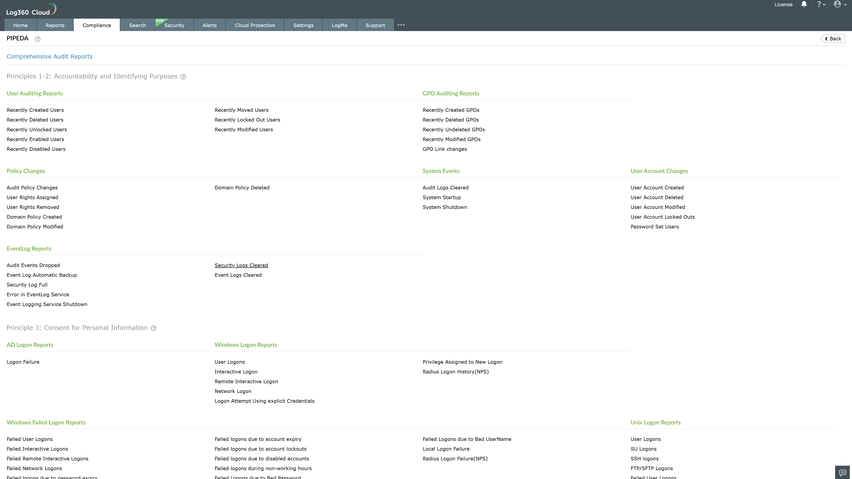
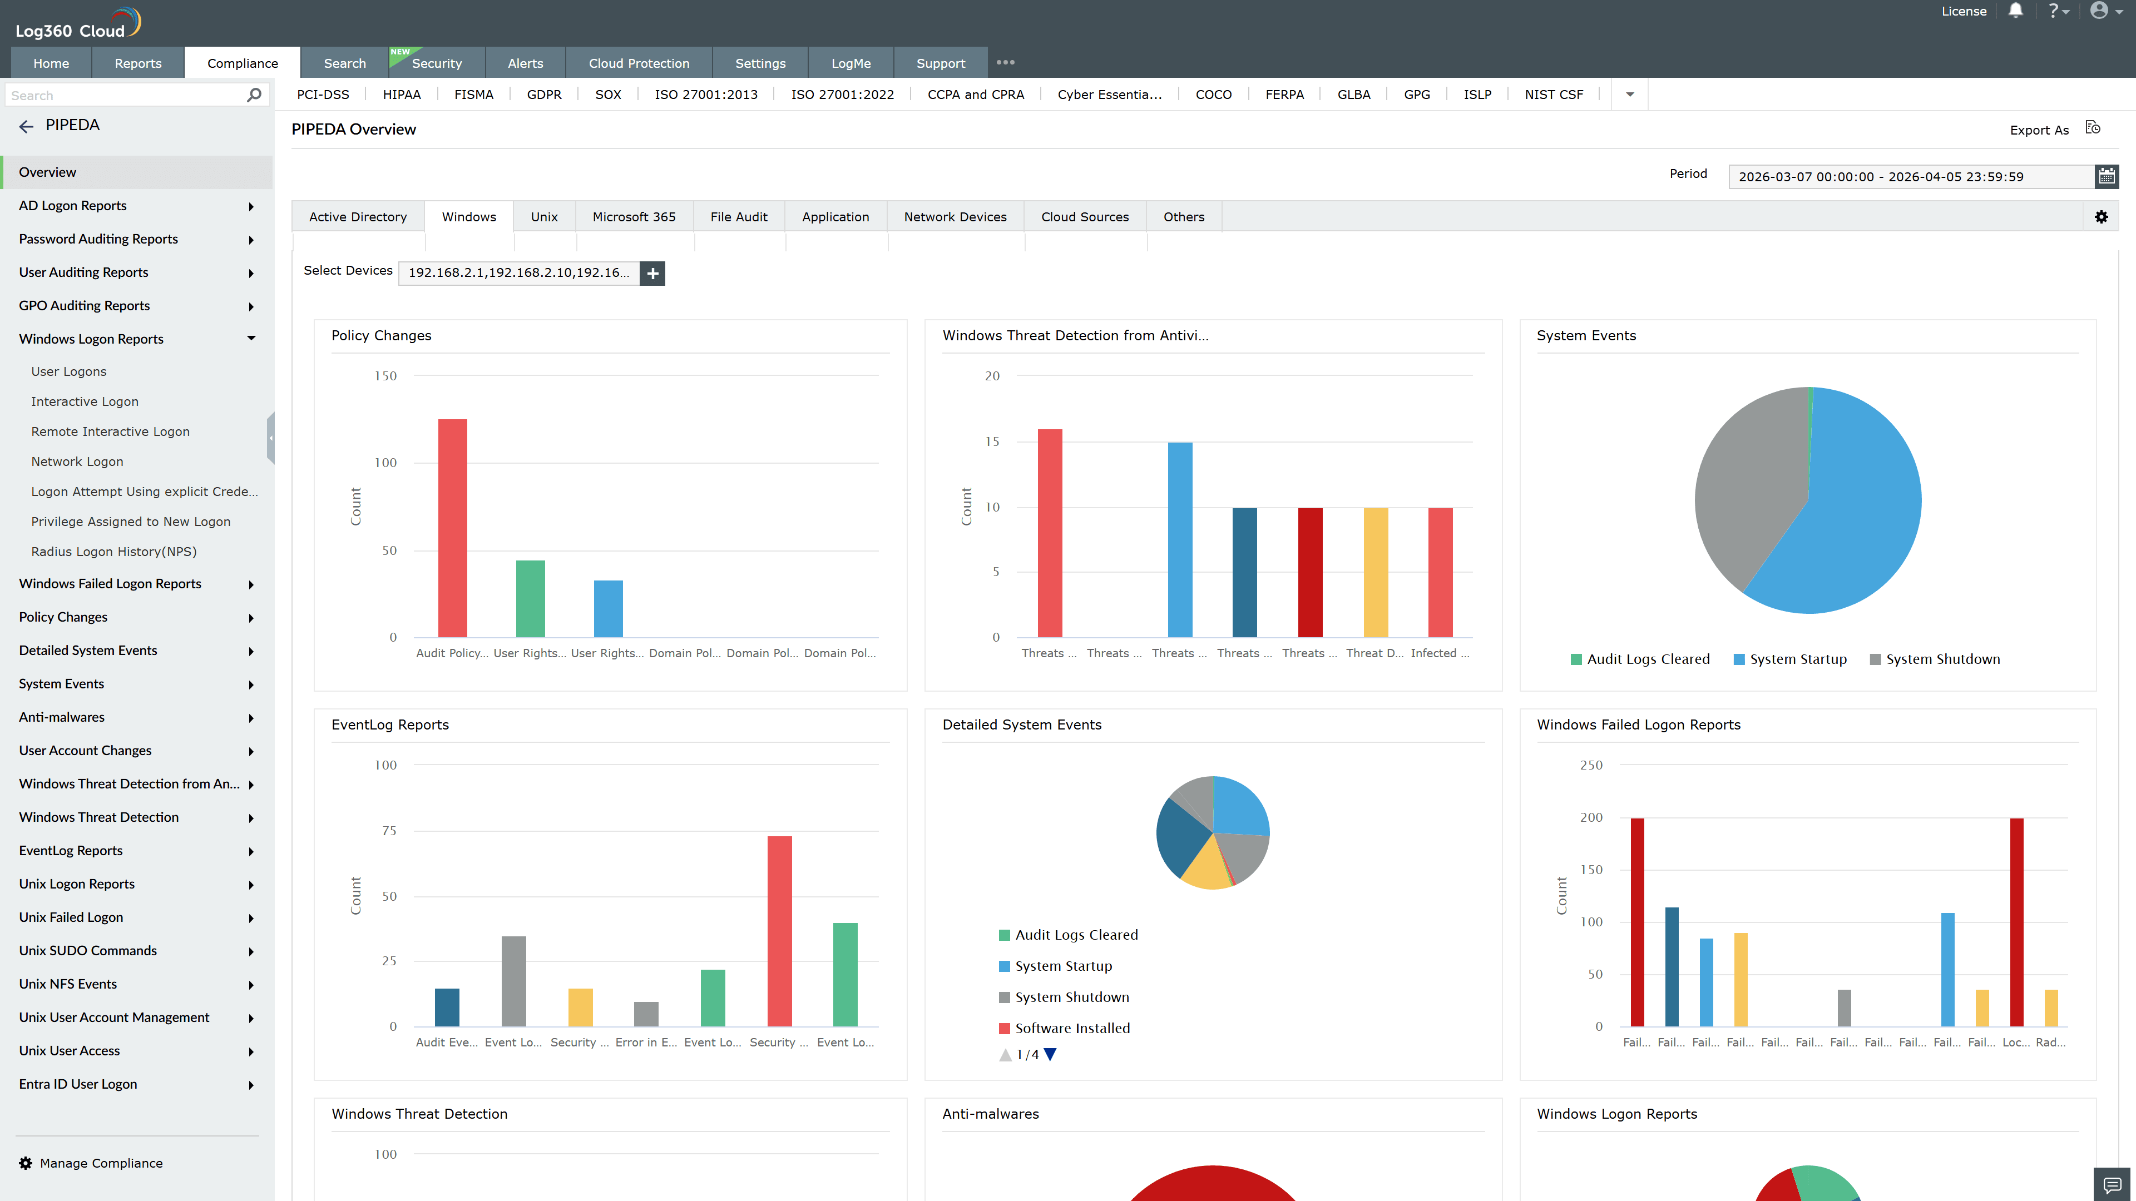
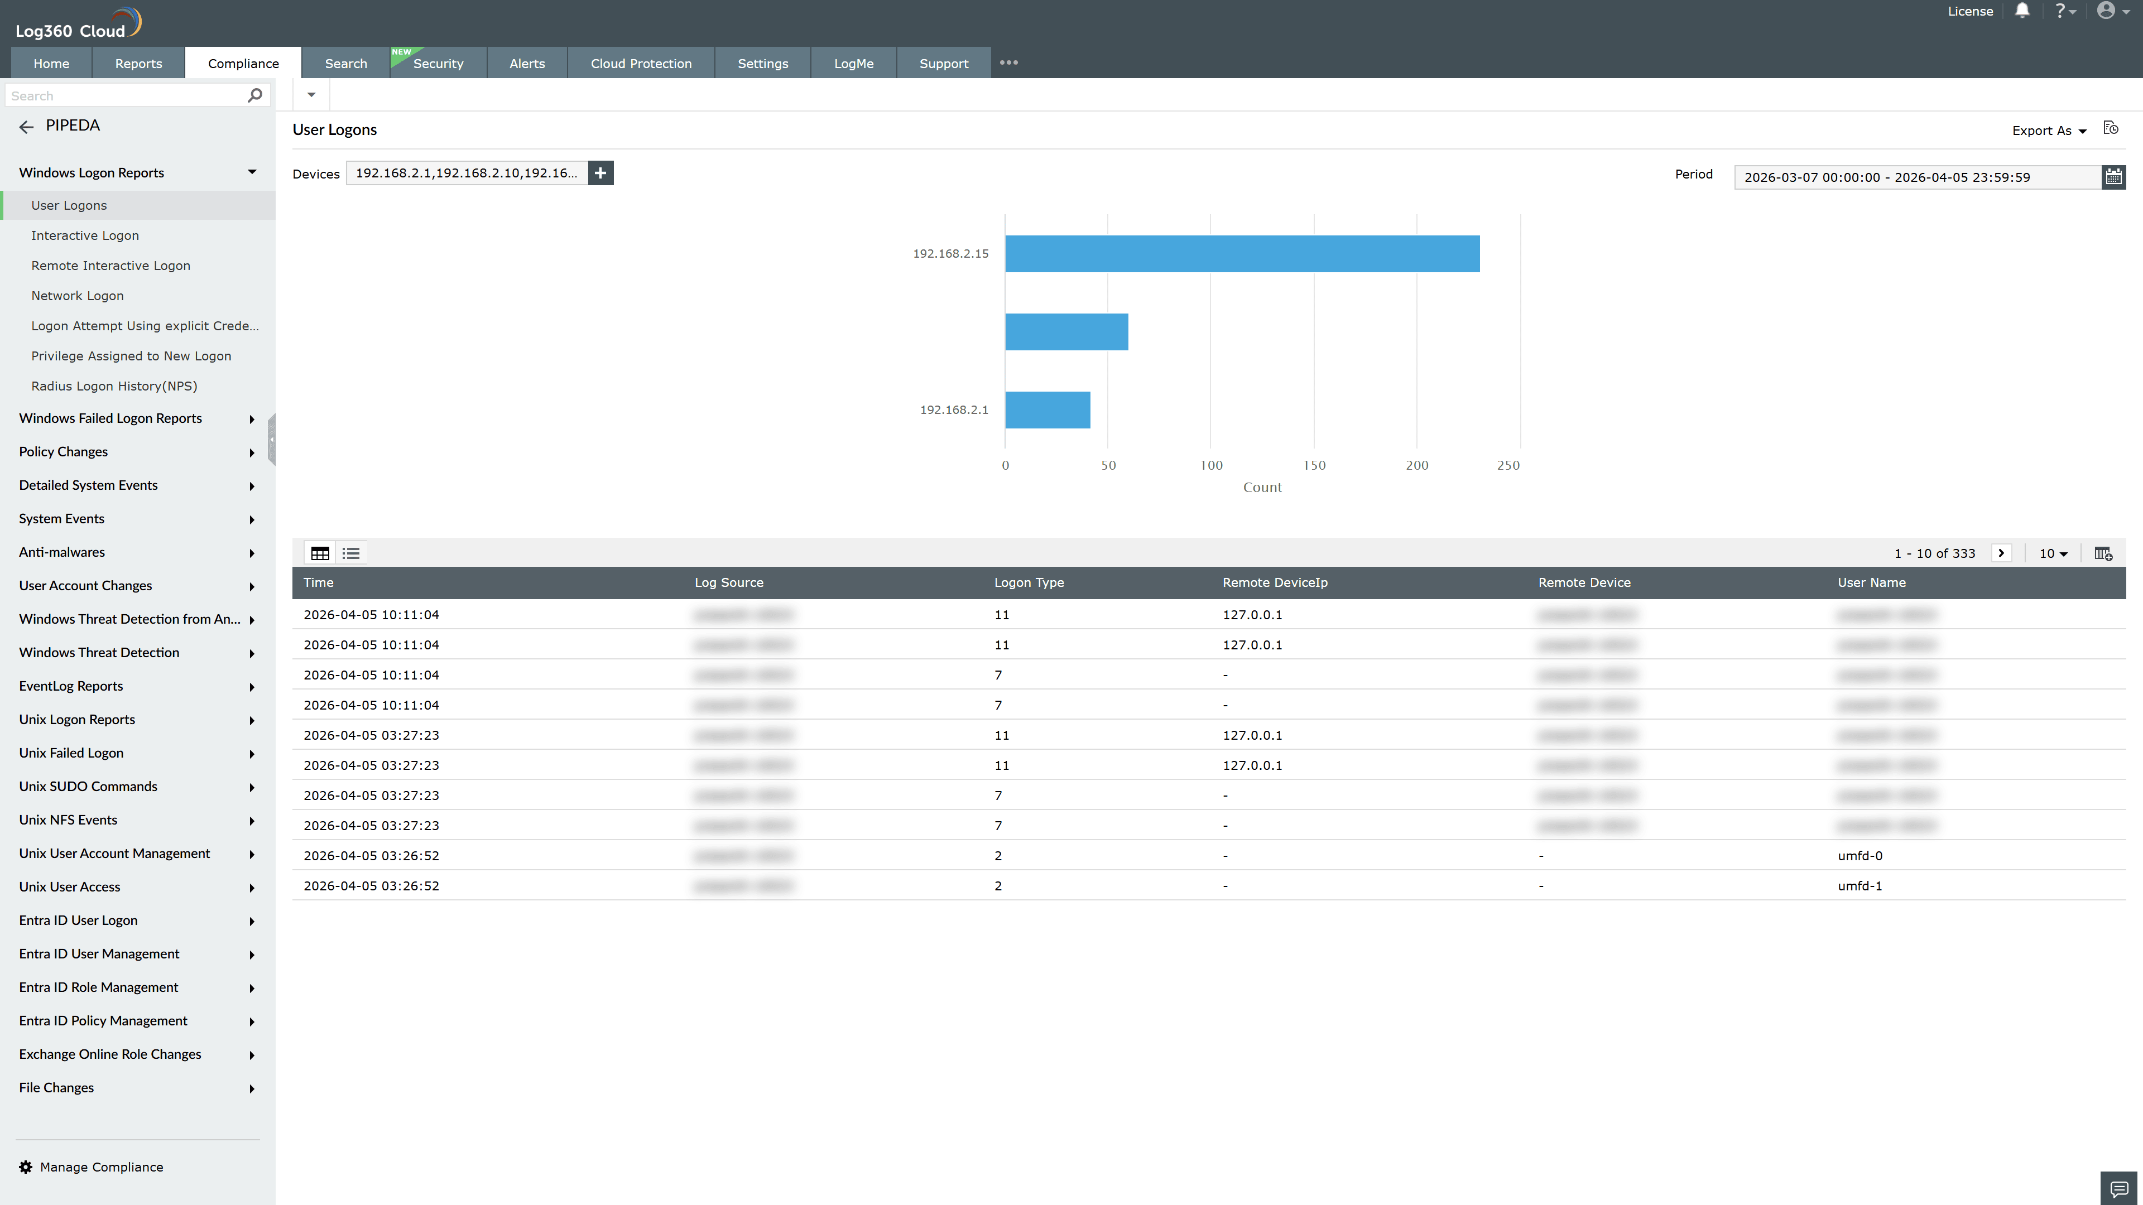
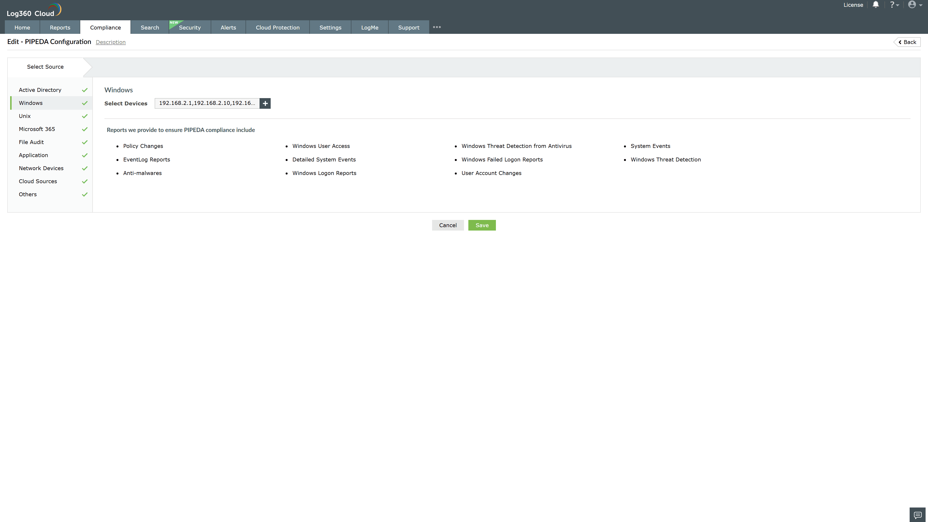
Valid Submission : Yes
Supported Editions : Free, Basic, Standard, Professional, MSSP
Help Document : https://www.manageengine.com/log-management/help/integrations/compliance-extensions.html
Help Video : Not provided
Tags : Log360, Compliance, Privacy monitoring, Data privacy, Regulatory compliance
Supported DCs : US, IN, JP, CA, AU, UK and EU
Privacy Policy:
Terms of Service:
Release Notes:
Predefined reports for the PIPEDA.

